Assignment 4

Q1

1. The code is stored in q1.py
2. The code contains a class ‘Node’ ,a class ‘SinglyLinkedList’ with a function ‘insert’ in it (except ‘__init__’) and a function ‘count_node’.
3. The code executes as follow:

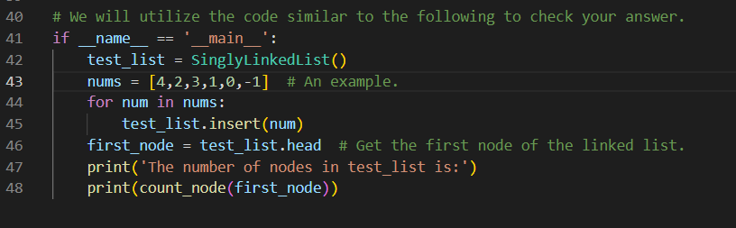

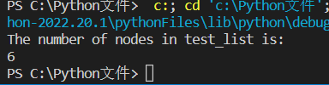

Q2:

1. The code is stored in q2.py.
2. The code contains a class ‘Node’, a class ‘SinglyLinkList’ with a function ‘insert’ in it (except ‘__init__’), a function ‘quick_sort’ and a function ‘getTail’.
3. The code executes as follows:

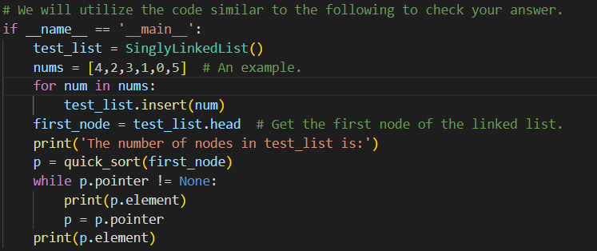

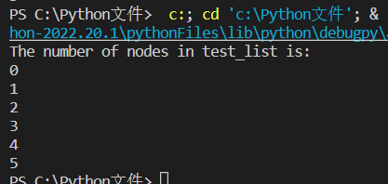

Q3

1. The code is stored in q1.py.
2. The code contains a class ‘Stack’ (with many functions), a ‘getBiggest’ function, a ‘getSmallest’, a ‘xtoy’, a ‘dif’, a ‘sp’, a ‘Hanoitower’.
3. The code executes as follows:

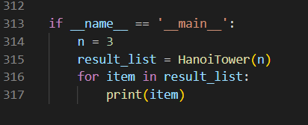

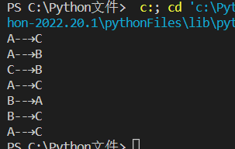

(The most important reason why there are more than 300 lines is that I don’t know rules of Hanoitower exactly and I played it depends on only a mysterious sense like ‘It should be there. It should be like this.’)